SEMINAR PROGRAMME 2022 DIPARTIMENTO DI CHIMICA “GIACOMO CIAMICIAN”

Catalysis Across M-M Bonds

Venerdì 2 Settembre, 2022

Aula II - 11:00
Link TEAMS

Dipartimento di Chimica “Giacomo Ciamician”
Via F. Selmi 2

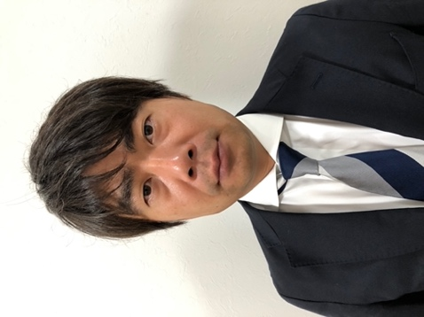

Prof. Yoshiaki NAKAO

Department of Material Chemistry
Kyoto University

